**Ideation Phase**

**Define the Problem Statements**

|  |  |
| --- | --- |
| **Date** | **16 October 2022** |
| **Team ID** | **PNT2022TMID28767** |
| **Project Name** | **IoT Enabled Smart Farming Applications** |
| **Maximum Marks** | **2 Marks** |

**Customer Problem Statement Template:**

Mr. Ram is a farmer with an Engineering background. He went to agricultural field with his father. Since he is a beginner in farming, he needs someone to guide him in the beginning and he plan to incorporate technology into farming to reduce the work and labour, and to improve productivity, more yield, suggestions to improve soil, and next crop planting ideas. He is actively researching a few agricultural products that solve his problem. These problems are common to many beginning and experienced farmers.

1. Who does the problem affect?
2. What are the boundaries of the problem?
3. What is the issue?
4. When does the issue occur?
5. Why is it important that we fix the problem?
6. What solution to solve this issue?
7. What methodology used to solve the issue?

These are the questions these can keep us in a correct way to approach our desire.

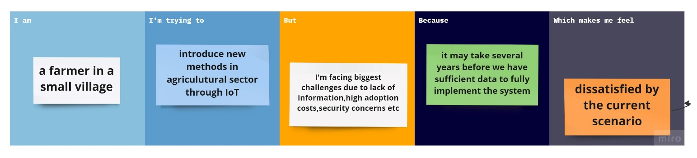

|  |  |  |  |  |  |
| --- | --- | --- | --- | --- | --- |
| **Problem Statement (PS)** | **I am (Customer)** | **I’m trying to** | **But** | **Because** | **Which makes me feel** |
| PS-1 | A Paddy cultivator | Cultivate more productivity using modern technique through IoT that can reduce labour work and make the desired outcome possible. | I can’t able to do it myself that much easily | It requires more internet connection and high power consumption | Not capable to do anything |
| PS-2 | A Farmer | Cultivate all types of vegetables by various organic methods. | Can’t able to do | One can’t make such a thing to become possible at the same time. | To think forward for new technologies that help to get more productivity and benefits. |